**Main source used for taking this note: Essential Biochemistry - Charlotte Pratt & Kathleen Cornely**

**Metabolic Pathways Overview**

**Metabolic pathways:** series of reactions that break down the monomeric compounds or build them up from smaller precursors.

**Glycolysis:** the pathway that degrades the monosaccharide glucose:

* The six-carbon sugar is phosphorylated and split in half, yielding two molecules of **glyceraldehyde-3-phosphate.**
* This compound is then converted in several more steps to another three-carbon molecule, **pyruvate**.
* The decarboxylation of pyruvate (removal of a carbon atom as CO2) yields **acetyl-CoA,** in which a two-carbon acetyl group is linked to the carrier molecule coenzyme A (CoA).

Glyceraldehyde-3-phosphate, pyruvate, and acetyl-CoA are key players in other metabolic pathways. For example,

* Glyceraldehyde-3-phosphate is the metabolic precursor of the three-carbon glycerol backbone of triacylglycerols.
* Pyruvate can undergo a reversible amino-group transfer reaction to yield alanine. Pyruvate can also be carbonylated to yield oxaloacetate, a four- carbon precursor of several other amino acids.
* Fatty acids are built by the sequential addition of two-carbon units derived from acetyl-CoA; fatty acid breakdown yields acetyl-CoA.

**Oxidation-Reduction in Metabolism:**

Many metabolic pathways include oxidation–reduction reactions,

For example:

* *The* ***catabolism*** *of amino acids, monosaccharides, and fatty acids is a process of* ***oxidizing carbon atoms****.*
* *The* ***synthesis*** *of these compounds involves* ***carbon reduction****.*

The **oxidation of carbon atoms** frequently appears as the **replacement of C—H bonds** (in which the C and H atoms share the bonding electrons equally) **with C—O bonds** (in which the more electronegative O atom “pulls” the electrons away from the carbon atom). Carbon has given up some of its electrons, even though the electrons are still participating in a covalent bond.

For example, the transformation of methane to carbon dioxide represents the conversion of carbon from its most reduced state (-4) to its most oxidized state (+4):

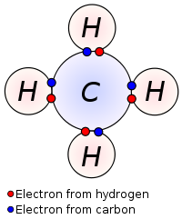(CH4)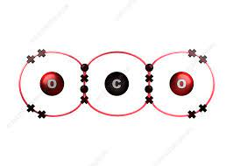(CO2)

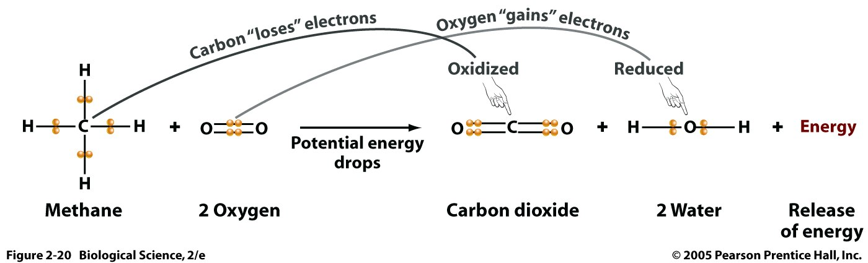

In **reduction processes**, the carbon atoms regain electrons as C—O bonds are replaced by C—H bonds. Turning CO2 into carbohydrate (CH2O) (reducing CO2) requires the input of free energy (think: sunlight). Therefore, ***the reduced carbons*** *of the carbohydrate represent a form of stored free energy.* This energy is recovered when cells break the carbohydrate back down to CO2.

* Reduction needs free energy. In other words, reduction is a process that stores energy in carbons, and oxidation is a process that releases energy from reduced carbons.
* Thinking in another way, reduction of carbons, for example, from +4 to -4, is a process that putting 8 electrons into carbon atom. As electrons carry energy, putting 8 electrons into carbon means that we store 8-electron equivalent amount of energy into carbon. Conversely, oxidization, or taking away 8 electrons, will release energy.

**Electron Carriers and Energy Transfer:**

In oxidation-reduction reactions, in some cases,

* **An electron** travels along with **a proton** as **an H atom**,
* Or **a pair of electrons** travels with **a proton** as **a hydride ion (H—).**

When a metabolic fuel molecule is oxidized (“fuel burnt to generate energy”), its electrons may be transferred to a compound such as nicotinamide adenine dinucleotide (NAD+) or nicotinamide adenine dinucleotide phosphate (NADP+). These are called **cofactors** or **coenzymes,** organic compounds that allow an enzyme to carry out a particular chemical reaction.

The redox-active portion of NAD+ and NADP+ is the **nicotinamide group**, which accepts **a hydride ion** **(H—)** to form NADH or NADPH. This reaction is reversible, so the reduced cofactors can become oxidized by giving up a hydride ion.

Because these electron carriers are soluble in aqueous solution, they can travel throughout the cell, shuttling electrons from reduced compounds to oxidized compounds.

Many cellular oxidation–reduction reactions take place at **membrane surfaces**. In these cases, a membrane-associated

enzyme may transfer electrons from a substrate to **a lipid-soluble electron carrier** such as ubiquinone (coenzyme Q). Ubiquinone’s hydrophobic tail, containing 10 five-carbon isoprenoid units in mammals, allows it to **diffuse within the membrane** todonate its electrons in another oxidation–reduction reaction.

**Oxidative Phosphorylation:**

**Catabolic** pathways, such as the **citric acid cycle**, generate considerable amounts of reduced cofactors.

* Some of them are re-oxidized in anabolic reactions.
* The rest are re-oxidized by a process that is accompanied by the **synthesis of ATP** from ADP and P*i*.

In mammals, the reoxidation of NADH and QH2 and the concomitant production of ATP require the reduction of O2 to H2O. This pathway is known as **oxidative phosphorylation.**

In effect, NAD+ and ubiquinone collect **electrons (and hence free energy)** from reduced fuel molecules. When the electrons are ultimately **transferred to O2**, this free energy is harvested in the form of ATP.

**Metabolism Outline:**

* Downward arrows represent catabolic processes, and upward arrows represent anabolic processes.
* Red arrows indicate some major oxidation–reduction reactions.
* The major metabolic processes are highlighted:

(1) Biological polymers (proteins, nucleic acids, polysaccharides, and triacylglycerols) are built from and are degraded to monomers (amino acids, nucleotides, monosaccharides, and fatty acids).

(2) The monomers are broken down into two- and three-carbon intermediates such as glyceraldehyde-3-phosphate, pyruvate, and acetyl-CoA, which are also the precursors of many other biological compounds.

(3) The complete degradation of biological molecules yields inorganic compounds such as NH4+, CO2, and H2O. These substances are returned to the pool of intermediates by processes such as photosynthesis.

(4) Electron carriers (NAD1 and ubiquinone) accept the electrons released by metabolic fuels (amino acids, monosaccharides, and fatty acids) as they are degraded and then completely oxidized by the citric acid cycle.

(5) The reduced cofactors (NADH and QH2) are required for many biosynthetic reactions.   
(6) The reoxidation of reduced cofactors drives the production of ATP from ADP 1 P*i*

(oxidative phosphorylation).

